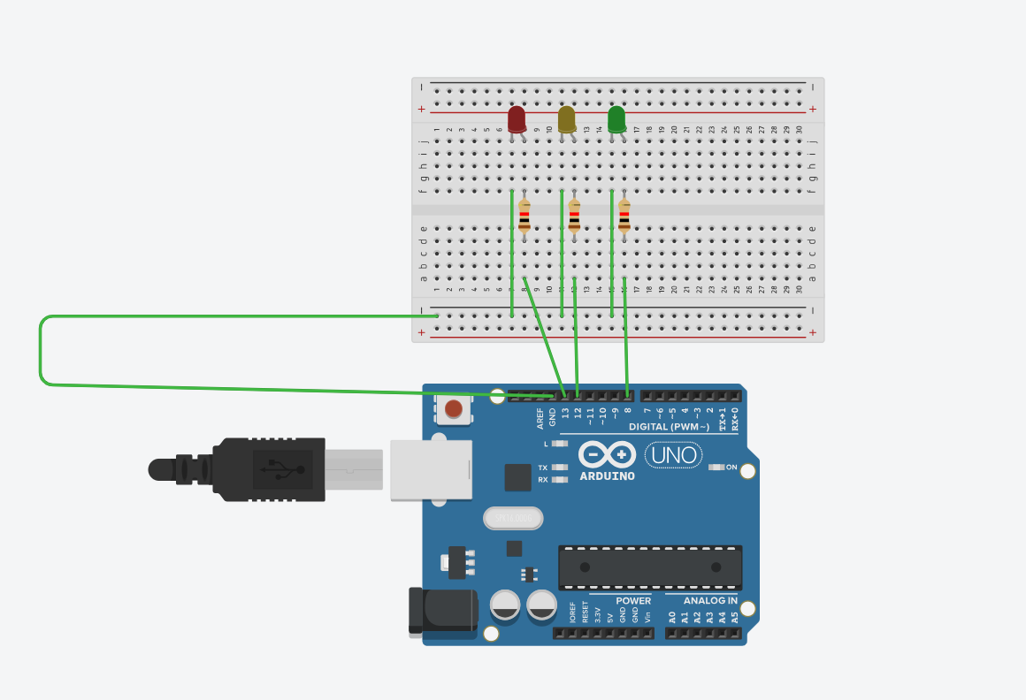
CODE:
int l1 = 13;
int l2 = 12;
int l3 = 8;

void setup() {
pinMode(l1, OUTPUT);
pinMode(l2, OUTPUT);
pinMode(l3, OUTPUT);
}

void loop()
{
digitalWrite(l1, HIGH);
delay(1000); // Wait for 1000 millisecond(s)
digitalWrite(l1, LOW);
delay(1000); // Wait for 1000 millisecond(s)

digitalWrite(l2, HIGH);
delay(1000); // Wait for 1000 millisecond(s)
digitalWrite(l2, LOW);
delay(1000); // Wait for 1000 millisecond(s)

digitalWrite(l3, HIGH);
delay(1000); // Wait for 1000 millisecond(s)
digitalWrite(l3, LOW);
delay(1000); // Wait for 1000 millisecond(s)
}

